**Blotto Swarm**

“Do I have to say something?”

― Eric Oh

There are 30 points located around a circle, and 10 castles are located on 10 of these points such that there are 2 points between adjacent castles. You and your opponent each have 50 soldiers which may move around the circle, and your goal is to have your soldiers occupy a majority at castles.

The game lasts for 100 days. On each turn, each soldier receives information about the number of ally and enemy soldiers in the 7 points closest to the soldier. (See figure on the next page) The soldier decides whether to move a point clockwise around the circle, counter-clockwise, or stay at the current point. At the end of the day, for each castle in which you have a majority of the number of soldiers occupying that point, you gain one point.

You are to implement one function *soldier*, which drives a single soldier.

* *soldier* takes as input two lists and one integer: *ally* and *enemy,* both of which are a list of 7 integers, and *offset,* which is an integer between -1 and 1.

Suppose that the soldier is located at point x (where x is taken modulo 30).

Then, *ally*[i] contains the number of ally soldiers at point x + i - 3. Notably, *ally*[3] contains the number of ally soldiers (including oneself) at point x.

Likewise, *enemy*[i] contains the number of enemy soldiers at point x + i - 3.

*offset* denotes the unique integer i between -1 and 1 such that a castle is located at x + i. It is worth noting that *soldier* does not know their absolute position x on the circle.

* *soldier* should output a single integer j between -1 and 1, indicating that the soldier wants to move to point x + j. In the event of an invalid output, the output will be treated as a 0.

An instance of *soldier* may store up to 16MB of memory, and use up to 0.5 seconds of time over 100 days. *soldier* will be called once every day for 100 days in total. At the end of each day, at each castle the player with a majority number of soldiers gains one point. After 100 days have elapsed, the number of points is tallied, and the player with more points wins.

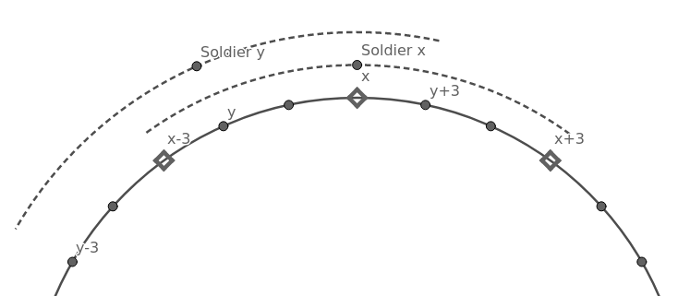

In this figure, diamond points are points on the circle with a castle. For soldiers x and y, the arc denotes the range of points they see.